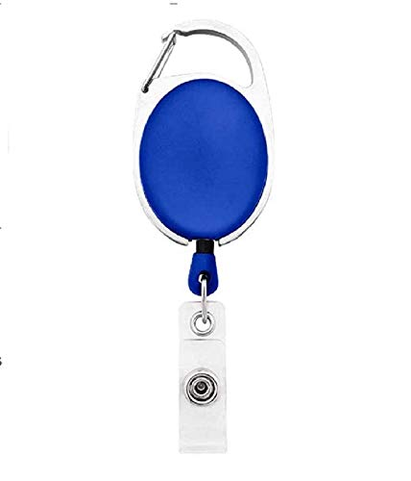



Rosie Pica | 
Finance
01/19/2022
A -ve
12345678

Questions / Queries – Drop an email to mailmukeshkala@gmail.com

